Q:1) what is 2+2 =?
Desc: description here
A:) 4
B:) 5
C:) 6
D:) 3
Answer:) A

Q:2) what is 2+6 =?
A:) 4
B:) 8
C:) 6
D:) 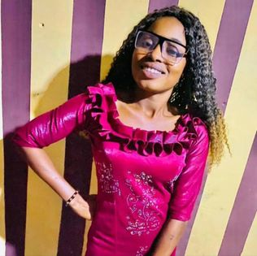
Answer:) B

Q:6) 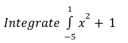
A:) 4 b:) 7 c:) 5 d:) -4
Answer:) B

Q:4) What is name of this guy in the picture below
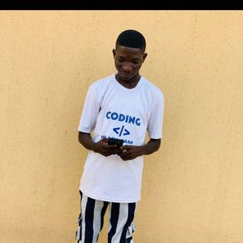

A:) Laotop b:) OLUOKUN KABIRU ADESINA c:) Brother Village Boy d:) Liadi Kafayat
Answer:) B

Q:5) What is the name of below image
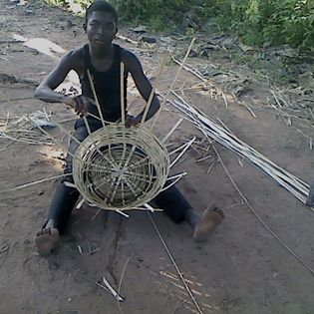
A:) basket b:) plate c:) apere d:) pot
Answer:) A

Q:3) Who is in the picture?
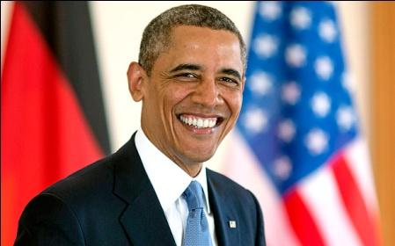

A:) Osama
B:) Obama
C:) Arvind
D:) Anil
Answer:) B

Q:4) What does this picture stand for?


A:) KOADIT
B:) Village Boy
C:) Kabir
D:) All of the above
Answer:) B

